MGMS – Project Tracking

Functional Specification Document

Ver. 1.4

Version History
Date | Description

Table of Contents

Version History 2
1 Introduction 4
1.1 Purpose 4
1.2 Scope 4
1.3 Assumptions 4
1.4 Constraints 4
2 Project Tracking/Closure 4
3 Business Rules 6
4 Status Messages 6

Introduction

Purpose

This document provides the requirements and functional specifications for the Project Tracking feature in Multisite Grant Management System project.
This is not a project plan or a design document. It is a guide for system architecture and development, not for phasing, timelines or deliverables.
Finally, this is a ‘living document’ and the specification will change, continuously, as the project proceeds. More details will be added and the existing information edited as the requirements, scenarios and use cases evolve in the course of the project.

Scope

Using this functionality the institution can record the status of its projects, at various points of project lifetime, finally setting the status “Close” when the project gets over. The project status and the percentage of completion will be saved against the date of the particular tracking entry and so also, any remarks by the user. These entries may be edited later on.

Currently the various project statuses possible are set by the back-end technical team and are common for all institutions and their projects. Future scope will consider providing the site administrators with a Masters option to add statuses for the specific institution/project. The order of statuses permissible can also be set then.
Future scope includes the provision to display graphically, the progress of the project based on the tracking records.

Assumptions
-None-

Constraints

Currently there is no check on the modification of project status records and they may be edited/ deleted at any time. Once the process flows are clearer, suitable validations can be put in to prevent this or an option to display the change log.

Project Tracking/Closure

At different points in a project lifecycle, the user may record the important milestones or status also indicating the percentage of completion of project as on that date.
The track record may also be edited.

Screen & Control Description

Figure 1: Project tracking/closure
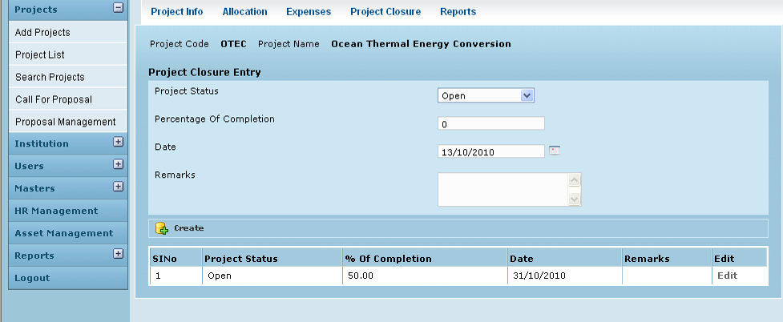

Field /Label | Input-Control | Data Type | Remarks/Edit Check
Project Code: | Auto populated | String
Project Name | Auto populated | String
Project Closure Entry
Project Status | Listbox | String | The values currently available are Open, Deadline passed, Grant funded, Closed
Percentage of Completion | Textbox | Number | Only positive numerical values less than or equal to 100
Date | Clendar | datetime
Remarks | Textarea | String
Create | Button
Sl No | Auto increment  populated
Project Status | Auto populated | String
Percentage of Completion | Auto populated | Number
Date | Auto populated | datetime
Remarks | Auto populated | String
Edit | Button |  | Opens the Project Closure Edit screen as shown below

Edit

Figure 2: Project tracking - Edit status
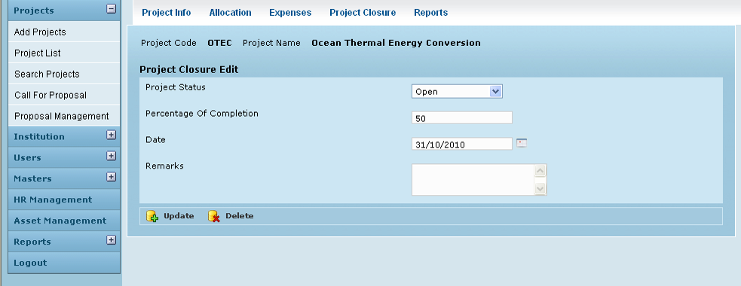

Field /Label | Input-Control | Data Type | Remarks/Edit Check
Project Code: | Auto populated | String
Project Name | Auto populated | String
Project Closure Edit
Project Status | Auto populated & editable | String
Percentage of Completion | Auto populated & editable | Number
Date | Auto populated & editable | datetime
Update | Button |  | Message: “Status edited successfully”
Delete | Button |  | Popup Message: “Are you sure?”. On clicking ok, the project closure entry screen is displayed with the specific line item is deleted

Business Rules

Any number of entries maybe made – even indicating same status but corresponding to different dates
Duplicate records not allowed.

Status Messages

Sl No | Status Message
1 | Created Successfully
2 | Updated Successfully
3 | Deleted Successfully
4 | The Requested Record Not Found
5 | The Record can't be deleted, Already in use
6 | The Record Already Exists
7 | Please Enter a valid email address
8 | You can not delete yourself, please login as another admin and try again
9 | Are you sure?

